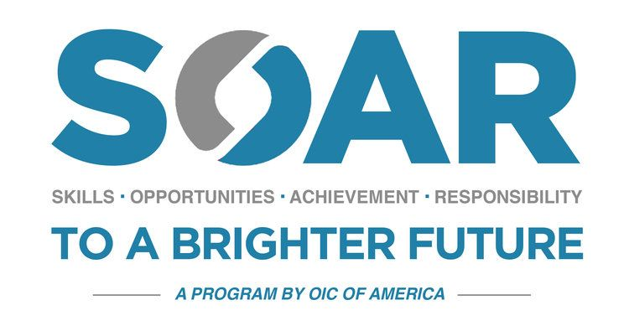

SOAR Case Management & Follow up Guidelines using COVID-19 Agency Status
Adopted June 15, 2020

There are two options for SOAR Case Management & Follow Up
Option 1.
Participants will be invited to case management and follow up sessions at Tri-County OIC by appointment only. Staff will follow social distancing measures. Participants while in the active phase will be contacted and encouraged to participate in at least one monthly activity with Tri County OIC SOAR staff, or a SOAR partner provider. The SOAR team will provide the participant with information and tools needed to meet the goals and actions of his/her Case Plan. Once the participant is placed in follow up status, the grant requires a nine-month follow-up period in which participants’ progress and any additional needs and services will be identified and provided. During the follow-up period, participants will meet one- on-one by appointment with a member of the SOAR team related to their risk/needs. Participants placed in employment will receive a weekly phone call for the first month of placement, the frequency thereafter will be guided by risk assessment results and other collateral information. Participants who do not secure employment or who secure part-time employment will be invited to Tri-County OIC by appointment only. Social distancing measures will be in effect. Participants will meet with a member of the SOAR team to receive additional employability skills training.
Option 2.
Participants will be invited to case management and follow up sessions via Zoom. The case management and follow up sessions will take place virtually. Participants while in the active phase will be contacted by the SOAR team to do remote case management over the phone or via Zoom call in a one on one setting at least once a month. A monthly activity will be scheduled for SOAR participants through Tri-County OIC SOAR staff, or a SOAR partner provider remotely. Once the participant is placed in follow up status, the grant requires a nine-month follow-up period in which participants’ progress and any additional needs and services will be identified and provided. During the follow-up period, participants will meet with a member of the SOAR team remotely as related to their risk/needs. Participants placed in employment will receive a weekly phone call or via Zoom call for the first month of placement, the frequency thereafter will be guided by risk assessment results and other collateral information. Participants who do not secure employment or who secure part-time employment will be invited to participate in weekly work readiness session to receive additional employability skills training.
The SOAR team will follow the Tri-County OIC COVID-19 Operations Policy procedures document to assure social distancing, sanitation, and health standards.

